SEMESTER ONE
Papers written by
Australian Maths Software

YEAR 12
MATHEMATICS METHODS
Unit 3
2017
Section Two
(Calculator–assumed)

Name: _________________________________

Teacher: ________________________________

TIME ALLOWED FOR THIS SECTION

Reading time before commencing work: 10 minutes
Working time for section: 100 minutes

MATERIAL REQUIRED / RECOMMENDED FOR THIS SECTION

To be provided by the candidate
Standard items: pens, pencils, pencil sharpener, highlighter, eraser, ruler.

Special items: drawing instruments, templates, notes on up to two unfolded sheet of A4 paper, and up to three calculators approved for use in the WACE examinations.

IMPORTANT NOTE TO CANDIDATES

No other items may be taken into the examination room. It is your responsibility to ensure that you do not have any unauthorised notes or other items of a non–personal nature in the examination room. If you have any unauthorised material with you, hand it to the supervisor before reading any further.

To be provided by the supervisor

Question/answer booklet for Section Two.
Formula sheet retained from Section One.
Structure of this examination

 | Number of questions available | Number of questions to be answered | Working time (minutes) | Marks available | Percentage of exam
Section One  Calculator—free | 7 | 7 | 50 | 52 | 35
Section Two  Calculator—assumed | 13 | 13 | 100 | 98 | 65
Total marks |  |  |  | 150 | 100

Instructions to candidates

1. The rules for the conduct of this examination are detailed in the Information Handbook.
Sitting this examination implies that you agree to abide by these rules.

2. Write your answers in the Question/Answer booklet.

3. You must be careful to confine your responses to the specific questions asked and to
follow any instructions that are specific to a particular question.

4. Spare pages are provided at the end of this booklet. If you need to use them, indicate
in the original answer space where the answer is continued i.e. give the page number.

5. Show all your working clearly. Your working should be in sufficient detail to allow your answers to be checked readily and for marks to be awarded for reasoning. Incorrect answers given without supporting reasoning cannot be allocated any marks. For any question or part question worth more than two marks, valid working or justification is required to receive full marks. If you repeat an answer to any question, ensure that you cancel the answer you do not wish to have marked.

6. It is recommended that you do not use pencil, except in diagrams.

7. The Formula Sheet is not to be handed in with your Question/Answer booklet.

8. (7 marks)
The velocity graph of a moving particle is shown below.
(a) Sketch the displacement – time graph and the acceleration-time
graph on the sets of axes provided. (2+2)
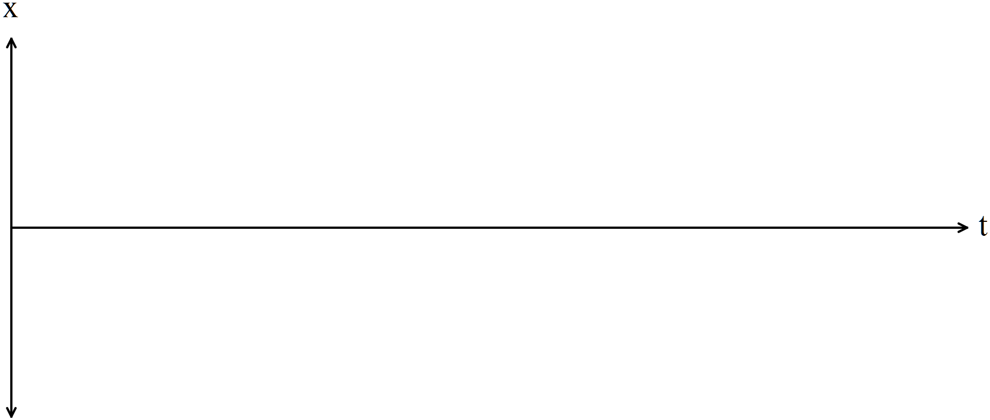
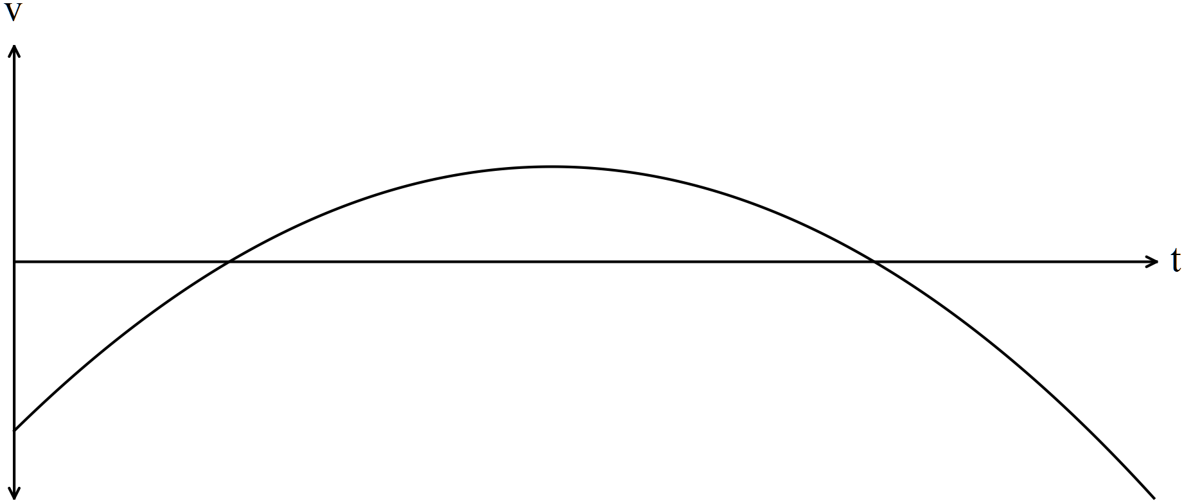
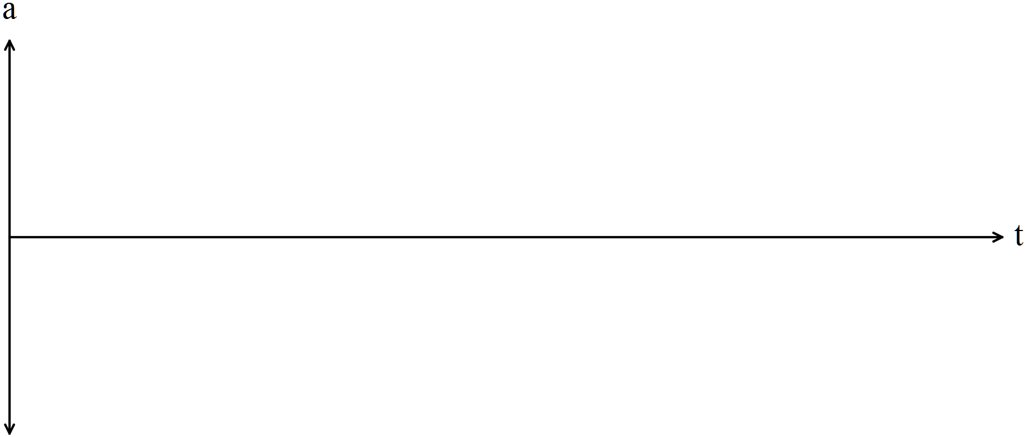
(b) State the relationship between the roots and turning point of 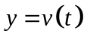with the
graphs of 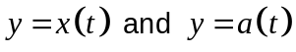 in (a). (3)
9. (6 marks)
The function is graphed in the diagram below and the signed area between
the function and theaxis is shown.

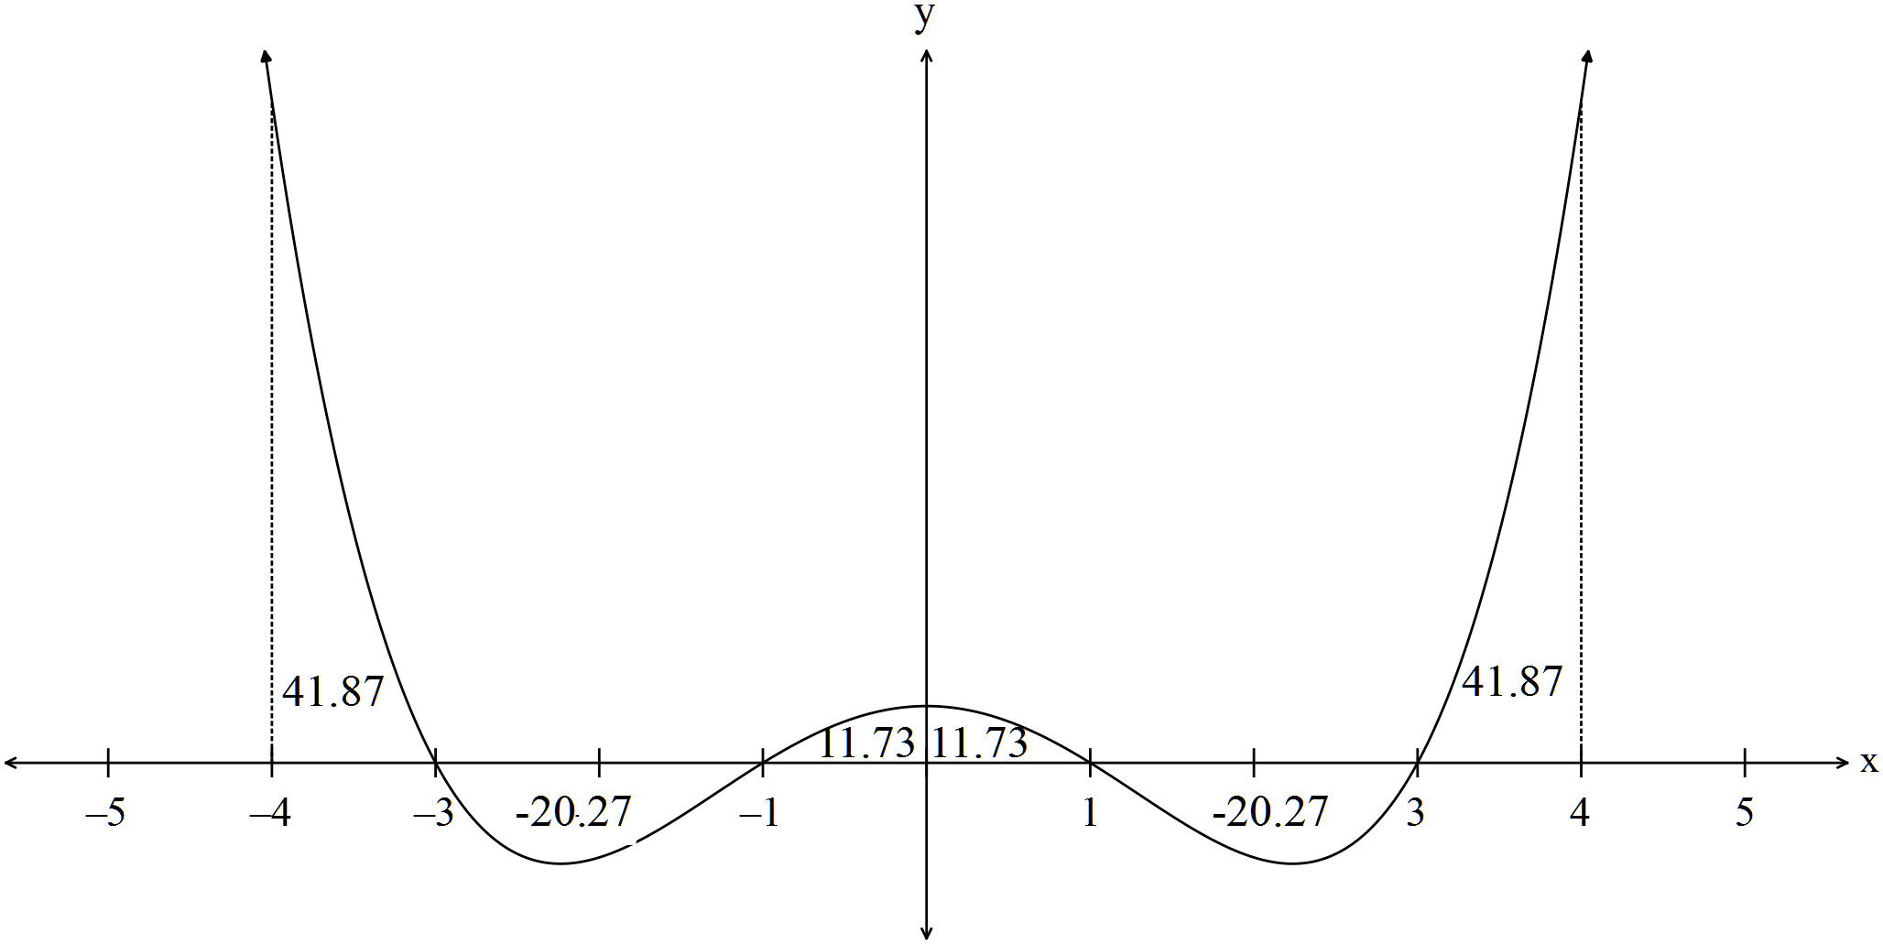
(a) Write down the value of each of the following
(i) 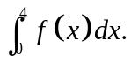 (1)

(ii) 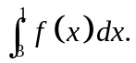 (2)

(iii) 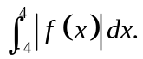 (2)

(b) Which of the expressions in (a) is an expression for the area between the
function, the axis and 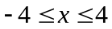? (1)

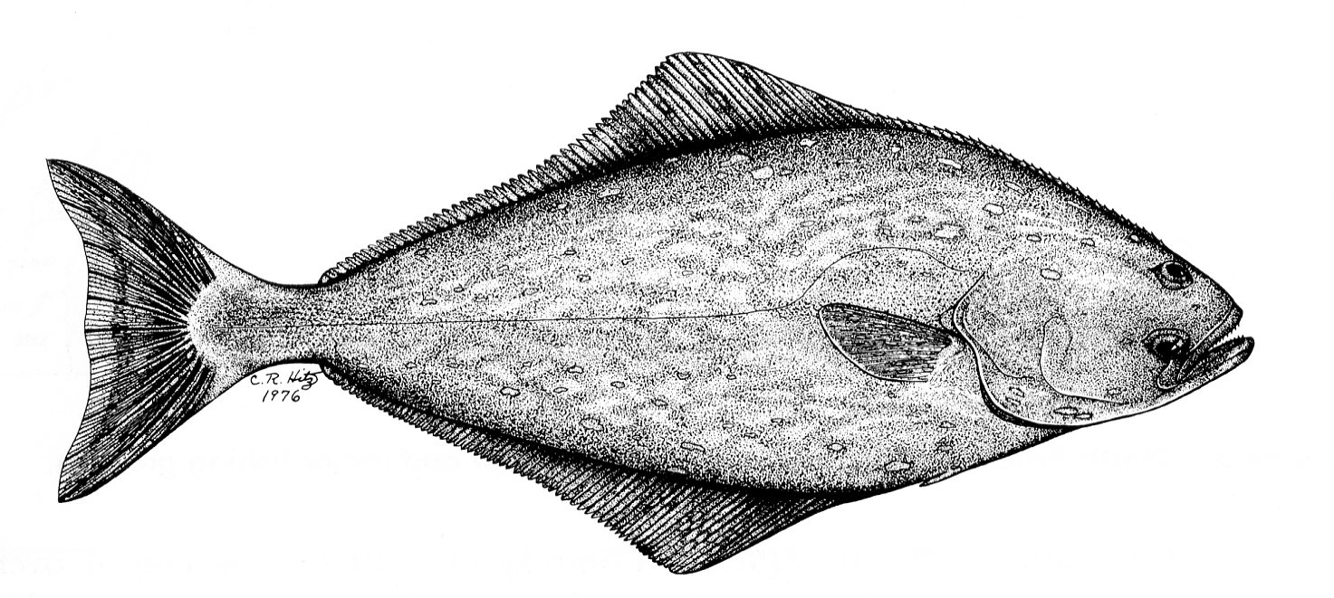
10. (6 marks)
The rate of growth of halibut is 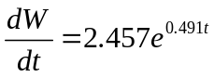 where 
is the weight of the fish in grams and the time in months.

(a) Find the expression for the weight of a halibut if it is expected to weigh 35.7
grams at 7 months. (3)

(b) Find the total change in the weight of a halibut between when it is 12 months old
and it is 15 months old. (3)

11. (11 marks)
The profit for the first few months of a company vary according to the function 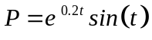, where t represents months.
Hint: Use radians.

(a) FInd the first and second derivatives of the profit function and explain exactly
how these derivatives could help you graph the function. (6)

(b) Sketch the profit equation on the set of axes. (3)

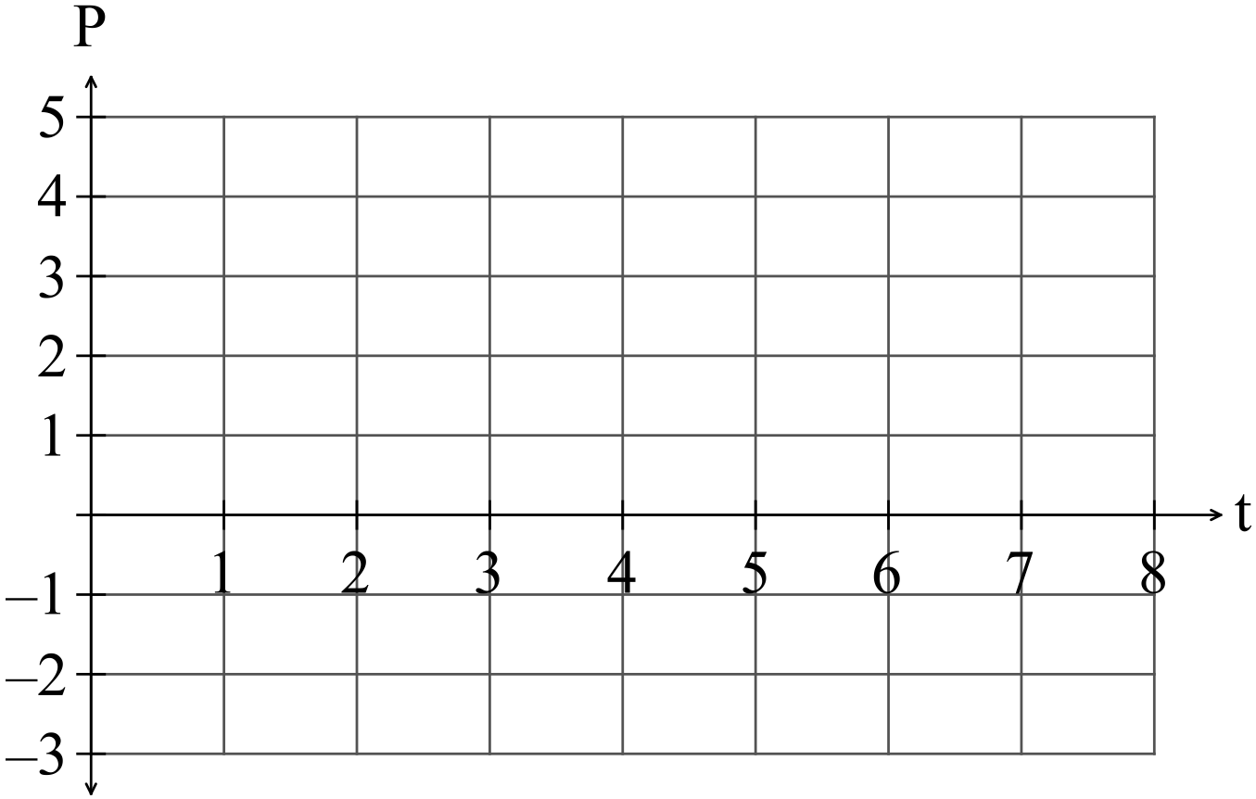

After the first two months when the profit had been increasing, the owner employed more staff and it took a little while for sales to start to increase again.
(c) Determine when the profit started to increase again. (1)

(d) Determine when the break even point was reached i.e. when profit again became positive. (1)

12. (10 marks)
(a) Consider the diagram below:

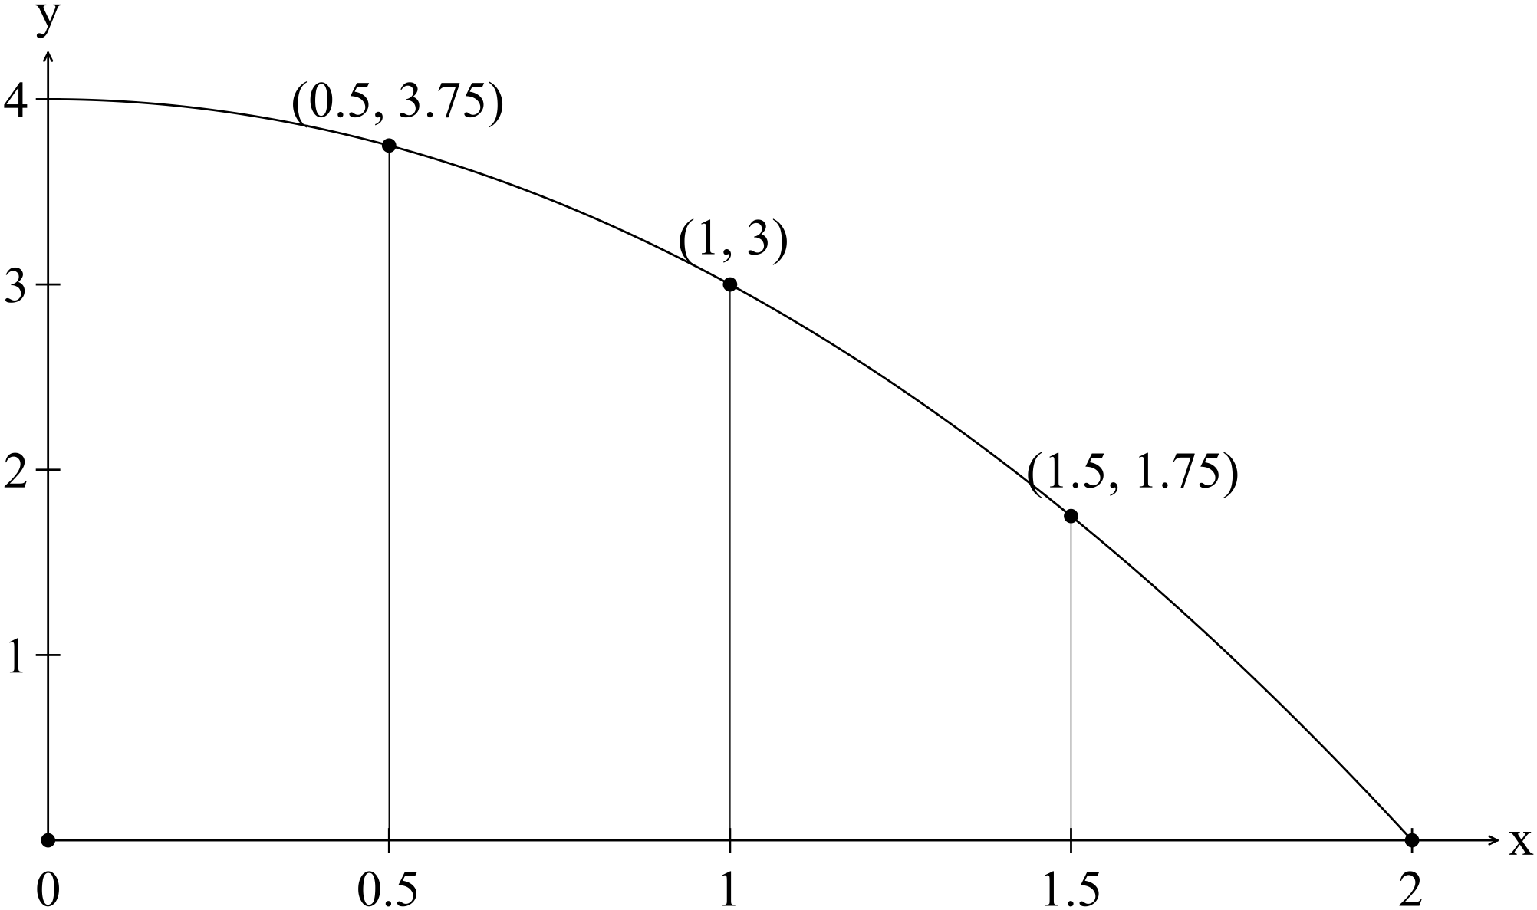

(i) Use the formula 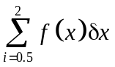 to obtain an underestimate of the area under
the curve on 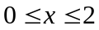. (3)

(ii) Write down an expression that is equivalent to
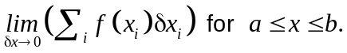
(2)

(b) (i) 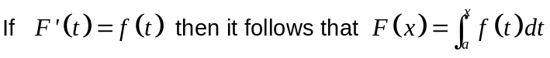
If 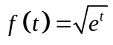 show that 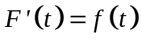 using the statement above. (3)

(ii) Find 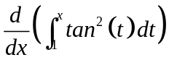. (2)
13. (5 marks)
Consider the triangle 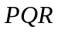below.
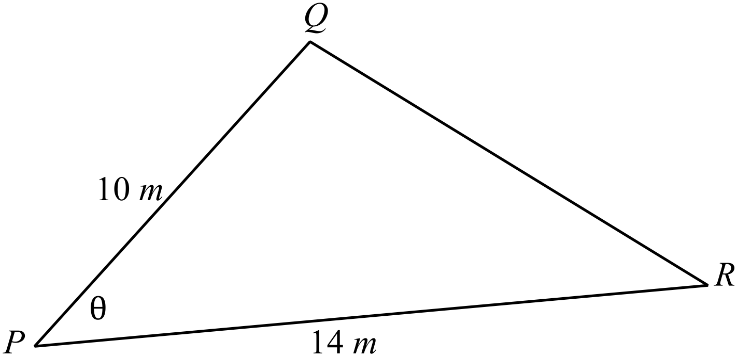
(a) Show that the area of the triangle can be given by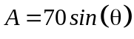. (2)

(b) If 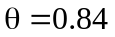radians but the measurement 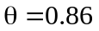was used,
use the incremental formula to determine the corresponding error in the area of
the triangle. (3)

14. (7 marks)
(a) Evaluate 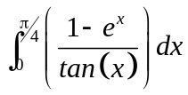 correct to three decimal places. (2)

(b) Given 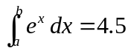 determine the value of 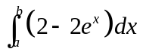 in terms of 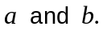
(3)

(c) Find 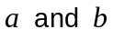 such that 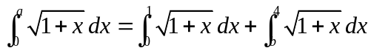. (2)

15. (8 marks)
Find the point (x, y) on the graph of 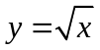that is closest to the point (4, 0). (8)
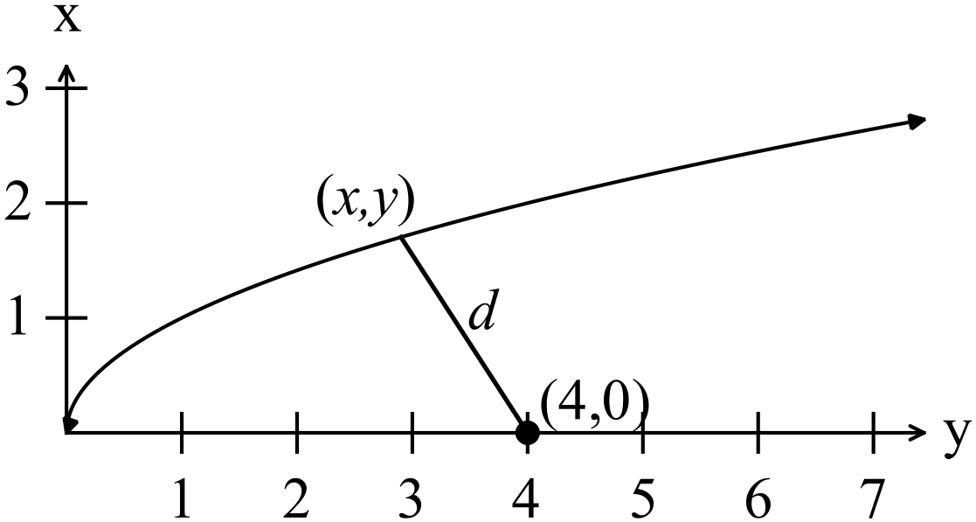
16. (5 marks)
In 1880, the population in the United States was 50 189 209.
In 1930, the population had increased to 123 202 624.
(a) Taking  in 1880, set up an equation in the form 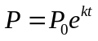 that can be used to estimate the population in the United Stated during the 50 year period. (2)

(b) Write down the average annual population growth over that period. (1)

Over the next 60 years to 1990, the population grew from 123 202 624 to 248 709 873.
(c) Determine if the rate of growth during the 60 years from 1930 to 1990 is the same as the rate of growth from 1880 to 1930. (1)

(d) Use the data from 1930 to 1990 to predict the population in 2016. (1)

NB. The actual population in 2016 was 324 118 787.
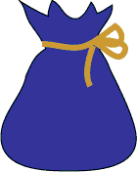
17. (4 marks)
Eight red marbles and 12 yellow marbles are placed in a bag
and mixed thoroughly.

One marble is selected and its colour noted then it is replaced
in the bag and mixed thoroughly with the other marbles again.
This process is repeated a number of times.
(a) What is the probability that the first yellow marble drawn is the fourth? (2)

A marble can be drawn up to four times. The draw stops once a yellow marble is
selected.
(b) What is the probability that a yellow marble is not drawn? (2)

18. (5 marks)
(a) Given 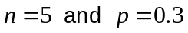, sketch the histogram of the binomial distribution for
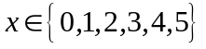 on the set of axes below. (4)

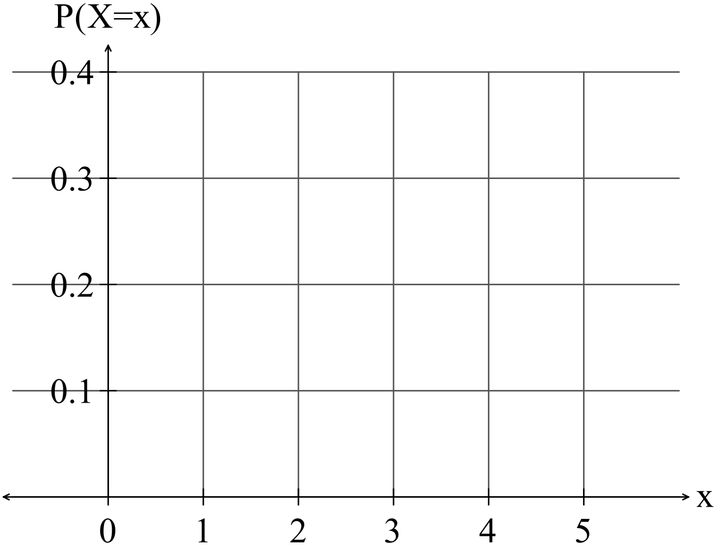

(b) Write down the value of p such that the skew is the same shape but in the
opposite direction. (1)

19. (10 marks)
(a) (i) Find the expected value and variance of the probability density function in
the table below. (5)

x | 1 | 2 | 3 | 4
P(X = x) | 0.3 | 0.2 | 0.2 | 0.3

(ii) The values of setare transformed so that 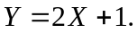
Write down the expected value and variance of set 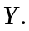 (2)

(b) Sam bet on the outcome of a spinner with probabilities as in the table
below.

x | 1 | 2 | 3 | 4
P(X = x) | 0.3 | 0.2 | 0.2 | 0.3

It costs Sam $1 per spin and the payout is $2 for a 2 or a 3 and nothing
otherwise.

What is Sam’s average payout? (3)

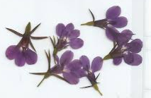
20. (14 marks)
Lobelia seeds produce either blue or white flowers.
Sixty percent of randomly selected lobelia seeds grow
into plants with blue flowers and the rest grow into plants with white flowers.
Ten seedlings with flowers of unknown colour were planted in a line in a planter.
(a) What is the expected number of blue flowering plants? (1)

(b) Determine the probability that four of the plants have blue flowers. (2)

(c) Determine the probability that at least four of the plants have blue flowers. (2)

(d) Determine the probability that at least 4 of the plants do not have blue flowers.
(2)

(e) Determine the probability that alternating plants have different coloured flowers.
(3)

(f) How many seedlings must be planted to have a 95% chance of obtaining at least two white flowering plants? (4)

END OF SECTION TWO
Extra page for working if necessary

